**Title:** If you’re rare, should I care? How imperfect detection changes relationships between biodiversity and global change drivers

**Author List:** Ana Miller-ter Kuile1,2, An Bui3, Austen Apigo4, Shelby Lamm1, Megan Swan5, Jamie S. Sanderlin2, Kiona Ogle1

**Author Emails:**

[ana.miller-ter-kuile@nau.edu](mailto:ana.miller-ter-kuile@nau.edu) (ORCID: 0000-0003-2599-5158)

[an_bui@ucsb.edu](mailto:an_bui@ucsb.edu) (ORCID: 0000-0002-9548-7776)

[aaapigo@uci.edu](mailto:aaapigo@uci.edu) (ORCID: 0000-0002-2525-0394)

[shelby.lamm@nau.edu](mailto:shelby.lamm@nau.edu) (ORCID: 0000-0002-9710-9023)

[megan_swan@nps.gov](mailto:megan_swan@nps.gov) (ORCID: 0009-0000-3467-022X)

[jamie.l.sanderlin@usda.gov](mailto:jamie.l.sanderlin@usda.gov) (ORCID: 0000-0001-8651-9804)

[kiona.ogle@nau.edu](mailto:kiona.ogle@nau.edu) (ORCID: 0000-0002-0652-8397)

**Author Affiliations:**

1 Northern Arizona University, School of Informatics, Computing and Cyber Systems, Flagstaff, Arizona, USA

2 USDA Forest Service Rocky Mountain Research Station, Flagstaff, Arizona, USA

3 University of California, Santa Barbara, Department of Ecology, Evolution, and Marine Biology, Santa Barbara, California, USA

4 University of California, Irvine, Department of Ecology and Evolutionary Biology, Irvine, California, USA

5 National Park Service Southern Colorado Plateau Inventory and Monitoring Network, Flagstaff, Arizona, USA

**Data availability:** Code for data preparation, analysis, and visualization can be found on Zenodo (<https://doi.org/10.5281/zenodo.13737499>).

**Running Head (45 characters):** Rarity alters drivers of biodiversity change

**Keywords (6-10):** multi-species occupancy model, multi-species abundance model, Bray-Curtis dissimilarity, functional richness, stability, species turnover, extinction, passerine birds, grasshoppers, understory plants

Journal aim: GCB Mini Reviews (3000 words abstract-acknowledgements, no figure limits specified)

**Abstract (300 words max)**

Across ecosystems and biomes, most species in a biological community are rare. Many biodiversity studies discount rare species when examining biodiversity patterns, assuming that common species are most influential for ecosystem functioning. There is growing evidence, however, that rare species contribute unique functions in many ecosystems; thus, discounting them produces misleading conclusions about how biodiversity is changing in the face of natural and anthropogenic forces. However, rare species are more likely to be missed by multi-species sampling designs and are thus particularly vulnerable to detection error. In this piece, we argue that best practice in biodiversity assessments should include rare species and account for error in the detection process. We outline a general approach that accounts for detection error in sampling designs using multi-species occupancy and abundance models (MSOM/MSAM). We then show how uncertainty in detection can be propagated from MSOM/MSAM results to derive more accurate estimates of alpha and beta diversity metrics. Finally, we show how uncertainty in these diversity metrics can be accounted for in follow-up regression models to evaluate relationships between biodiversity and global change covariates. Using three case studies across diverse taxa (birds, insects, and plants), we demonstrate how accounting for the detection process alters the relationships between biodiversity and global change drivers in ways that are important for understanding and predicting ongoing and future change in these communities. Our aim in this mini review is to provide a generalizable analysis approach for biodiversity studies and show how it impacts our understanding of global biodiversity.

**1 | INTRODUCTION**

Most species in natural ecosystems are rare (Rabinowitz, 2014 Figure 1). Historically, rare species have often been excluded from analyses of biodiversity under the assumption that more abundant or common species contribute most to ecosystem functioning (Poos & Jackson, 2012; Sasaki & Lauenroth, 2011). But, there is growing evidence that rare species are important for understanding relationships between biodiversity and ecosystem functioning and services (Dee et al., 2019; Mouillot et al., 2013). For example, rare species disproportionately influence functional diversity (Jain et al., 2014; Leitão et al., 2016; Roth et al., 2018) since these species often have unique trait combinations (e.g., large-bodied long-distance seed dispersing birds in Australia, Leitão et al., 2016). Thus, including rare species in biodiversity assessments may fundamentally change our understanding of how ongoing and future global change will shape ecosystems (Jaureguiberry et al., 2022).

Incorporating rare species into biodiversity metrics may alter predictions about many facets of biodiversity since rare species may have unique responses to environmental perturbations (Säterberg et al., 2019). However, many multi-species observational datasets, even those with long temporal or broad spatial coverage, do not incorporate survey designs to capture rare or patchy species distributions (Devarajan et al., 2020; Jeliazkov et al., 2022; Sanderlin et al., 2014; Zipkin et al., 2010). As a result, many multi-species sampling methods are likely to systematically miss rare species. A challenge to incorporating rare species is the possibility of "false negatives": species or individuals are present but considered absent because they are not detected during a survey (Zipkin et al., 2010). Thus, when we examine biodiversity patterns and try to identify environmental factors influencing biodiversity, our analyses may be biased by weaknesses of the sampling design, making it challenging to discover real biological patterns. Not considering rare species in biodiversity-global change assessments may alter our predictions of the direction, magnitude, and timescales of influence of global change drivers on biodiversity.

Biodiversity assessments could benefit from accounting for imperfect detection of species, especially those that are rare. We outline a general approach that leverages established modeling methods that account for imperfect detection (Bayesian multi-species occupancy and abundance models; (Dorazio et al., 2006; Iknayan et al., 2014) to generate unmeasured (“latent” or “true”) abundance and occupancy estimates from observed data with detection error. We then show how these “true” (latent) estimates can be subsequently used to generate biodiversity metrics (including both alpha and beta diversity), thus propagating uncertainties associated with the detection error process to accurately describe community-level diversity patterns. These diversity estimates (means and variances) can be subsequently analyzed via regression models to evaluate how potentially important covariates impact community diversity. Our regression modeling approach also captures the lagged effects of environmental drivers using a stochastic antecedent modeling framework (Ogle et al., 2015; Figure 2). Using this multi-step process, we demonstrate how accounting for imperfect detection of all species (especially rare species) alters estimates of global change driver effects – direction, magnitude, and timescales of influence – using three examples of long-term community datasets representing a variety of taxa (plants, invertebrates, and vertebrates).

2 | ACCOUNTING FOR DETECTION ERROR

Accounting for detection error in observational datasets of species occurrence or abundance is not a new concept (e.g., (Dorazio et al., 2006; Kéry & Schmidt, 2008; MacKenzie et al., 2002; Royle et al., 2005). Across fields, researchers have acknowledged that it can be difficult to detect all components (e.g., species) in their ecosystems and have proposed a suite of approaches for dealing with this problem. For multi-species datasets, it is common to use multi-species occupancy and abundance models (MSOM/MSAM) that “correct” observed data to estimate latent “true” values of occurrence (occupancy) or abundance. These models typically include two parts: (1) an observational process model that accounts for uncertainty in the observed data using covariates that could alter detection probabilities, and (2) a biological process model that is informed by the detection error process in (1), producing latent (unmeasured) “true” occupancy or abundance estimates that can, in turn, be modeled as a function of biological covariates (Figure 2). These models allow rarer species in a community to “borrow strength” from more common species by allowing species-level parameters to be modeled hierarchically around community- or group-level parameters (Iknayan et al., 2014; Ogle et al., 2013). These models account for “false negatives” and generally shift latent species abundance and frequency distributions to higher values relative to observed values (Figure 3). This approach has been applied often in studies of vertebrate communities (i.e., Kellner & Swihart, 2014) but is not common practice in community ecology at large, especially for invertebrates and plants; but see (Chen et al., 2013). Moreover, there is an opportunity to use the species-level latent abundance or occupancy estimates to produce realistic estimates of biodiversity that account for detection errors at the species level, but aside from a few studies focusing on species richness (Dorazio et al., 2006; Tingley et al., 2020), this approach has generally not been applied to other diversity metrics; but see (Broms et al., 2015; Cannon et al., 2019; Si et al., 2018).

3 | GENERATING VALUES OF ALPHA AND BETA DIVERSITY

Once detection errors have been accounted for via a MSOM or MSAM, the latent (“true”) occupancy and abundance of each species in a community can be used to generate a variety of biodiversity metrics common in community ecology, including measures of alpha and beta diversity based both on occurrence and abundance values (e.g., species richness, Shannon’s diversity, Berger-Parker dominance, Bray-Curtis dissimilarity, and Jaccard dissimilarity; (Baselga, 2013; Hallett et al., 2016; Morris et al., 2014; Oksanen et al., 2020); Figure 3). Further, occupancy probabilities can also be used as a proxy for relative abundances (e.g., Broms et al., 2015). The Bayesian statistical framework in which these models are commonly implemented, draws from the posterior to generate a set of independent samples for all stochastic quantities of interest, including the latent abundance or occupancy values (or probabilities). Via analysis of the posterior distributions, resulting biodiversity metrics can be described in terms of both their central tendency (mean or median) and their variance (e.g., standard deviation, Bayesian credible intervals; (Ellison, 2004)).

4 | EVALUATING DRIVERS OF BIODIVERSITY PATTERNS

Importantly, the uncertainty in estimates of biodiversity generated from multi-species models can be propagated to downstream analyses. Many diversity indices (including alpha and beta diversity) are defined on the (0,1) interval (Oksanen et al., 2020). Thus, we describe a general Bayesian model framework that uses a beta distribution to model the stochastic diversity indices (Ferrari & Cribari-Neto, 2004; Irvine et al., 2016). However, any distribution appropriate for other stochastic “data” types (e.g., Poisson for species richness, gaussian for Shannon diversity) can be incorporated into this modeling framework. Because biodiversity responses to environmental drivers stem from complex population and community processes related to resource availability, competition, species-specific life history, and food web dynamics, among others, it is likely that biodiversity could have a lagged response to potential drivers (Figueiredo et al., 2019, Thompson & Ollason, 2001, Essl et al., 2015a, Essl et al., 2015b). We can explicitly test for these lagged responses by combining the beta data model with a stochastic antecedent model (SAM) that provides estimates of covariate effects, where the covariates are, in turn, modeled as a weighted average of concurrent and past values. Each lag period gets an estimated importance weight describing its relative influence on the biodiversity response (Ogle et al., 2015).

5 | APPLYING THE COMBINED MODELING FRAMEWORK

Combining multi-species models with regression models applied to biodiversity metrics provides a powerful framework for accounting for detection error of rare species. Here, we derived values of biodiversity for three examples in two ways: (1) using observational data without accounting for detection error and (2) using the above modeling framework. These examples illustrate that accounting for imperfect detection alters predictions of the direction, magnitude, and temporal scale of effects of many environmental covariates on multiple biodiversity metrics across a diverse range of environments and biological communities. These differences stem largely from the inclusion of rare species. Our aim is not to provide comprehensive ecological analyses of these communities, but rather, to illustrate the utility of the combined modeling approach; we provide a detailed description of this framework in the Supporting Information (*Materials and Methods*).

We chose gold standard, long-term ecological survey and monitoring data that meet the assumptions for multi-species models (e.g., multiple surveys within “closed” timeframes) and that have sufficient temporal coverage (15-20+ years) to examine the influence of long-term variability in climate drivers. Further, all datasets represent surveys that captured >95% of the total species pool likely present in each meta-community, based on rarefaction (Figure S1), thus allowing us to calculate diversity metrics based on a known species pool (Tingley et al., 2020). The Supporting Information provides details on the data processing for all three examples (see 1.5 in the SI) and results for additional diversity metrics (Figures S2-S4). We also provide an online tutorial on how to apply our modeling approach (https://an-bui.github.io/community_detection_tutorial/).

**5.1 | Functional richness of bird communities at the Konza Prairie Long-Term Ecological Research (LTER) Site, Kansas, USA**

Functional diversity metrics describe communities in terms of how the organisms in that community contribute to ecosystem functions such as nutrient cycling and storage (Mammola et al., 2021). Studies have shown that rare species are important for these metrics (Leitão et al., 2016; Mouillot et al., 2013), since rare species can often represent unique trait combinations (i.e., larger animals are rarer and disperse larger seeds (Donoso et al., 2020).

In this example, we examined Rao’s quadratic entropy, an abundance-based metric of functional richness of grassland passerine bird communities at Konza Prairie LTER, Kansas, USA (Boyle, 2023; Bruckerhoff et al., 2020; Nippert, 2023; Tobias et al., 2022). Rao’s quadratic entropy increased slightly when accounting for detection error (Figure 3). Rather than there being a delayed positive effect of precipitation on Rao’s quadratic entropy, accounting for imperfect detection of species demonstrates that, in fact, the precipitation effect acts more quickly. Further, temperature has a much stronger effect on functional diversity of grassland birds and is most important in the shoulder seasons (spring and fall; Figure 4). Accounting for detection error shifts the ecological interpretation of patterns in this system from being a smaller set of simpler potential mechanisms, such as precipitation leading to increases in abundance or diversity of spring resources that trigger increased nest success or earlier migration (Marra et al., 2005; McKinnon et al., 2012) to a complex potential suite of mechanisms. These mechanisms could include early emergence of diverse or abundant food resources triggered by precipitation prior to the nesting season, changes or mismatches in the phenology of birds and resources (e.g., migration and emergence/germination) in warmer springs or falls, or increased competition among birds when warm spring or fall conditions lead to more limited food options (Illán et al., 2014; Kokko, 1999; Studds & Marra, 2011).

5.2 | **Occurrence-based stability of plant communities in Petrified Forest National Park, Arizona, USA**

Community stability describes how biodiversity changes through time (Loreau & de Mazancourt, 2013). One way of quantifying stability is through changes in species occurrence over time (“turnover”), which can be partitioned into local extinction and colonization (Hallett et al., 2016). Rare species are more likely to go locally extinct due to small population sizes and relative isolation from other conspecific patches (e.g., (Matthies et al., 2004)); therefore, improved estimation of their presence helps to better represent local extinction events.

In this example, we examined temporal patterns of species losses based on occurrence data for understory plants in Petrified Forest National Park, Arizona, USA. These data come from the National Park Service’s Inventory and Monitoring program (Swan & Ploughe, 2023). Accounting for imperfect detection increased estimates of losses (Figure 3), likely because rare species were better accounted for in the community. When we do not account for imperfect detection, indices of moisture status – precipitation and vapor pressure deficit (VPD) - did not impact species losses in this water-limited ecosystem (Figure 5). Conversely, when accounting for imperfect detection, both VPD and precipitation had positive effects on species loss. Both of these drivers have seasonal signals on species loss, with summer VPD, summer precipitation, and winter precipitation having the greatest effects (Figure 5). High precipitation in the summer and winter can shape competitive dynamics; highly abundant annual plants may take advantage of improved access to moisture, potentially outcompeting more rare species (Kadmon, 1995). The temporal signals for both VPD and precipitation extended through two summers, suggesting that dynamics of reproduction, growth, competition, and thermal or drought stress can have relatively long “memories”, even in communities with shorter-lived plants (Fernández‐Pascual et al., 2019; Walter et al., 2011).

**5.3 | Abundance-based stability of grasshopper communities at the Sevilleta LTER, New Mexico, USA**

Another way temporal stability is examined is through abundance-based beta diversity metrics (e.g., Bray-Curtis dissimilarity between time points at a site, Oksanen et al., 2020). While abundance-based metrics are shaped mostly by common species (Brasil et al., 2020), better accounting for all species is likely to alter these estimates.

In this example, we examined temporal variability in beta diversity of grasshopper communities at Sevilleta LTER from 1992-2019 (Baur et al., 2022; Lightfoot, 2021; Moore & Hall, 2023). We estimated greater abundance-based stability (smaller values of Bray-Curtis dissimilarity) when accounting for detection error (Figure 3). Potentially because of this reduction in Bray-Curtis dissimilarity, we estimated a weaker effect of all three covariates (precipitation, temperature, and plant biomass) on community stability (Figure 6). Further, we discovered shifts in the temporal signals of all covariates, including a shift to a more delayed effect of plant biomass, a change to a dry season precipitation signal (versus wet season), and a faster temperature signal. Grasshopper community dynamics are driven by complex interactions among environmental drivers that vary across species with different food preferences and life histories (Branson, 2008; Guo et al., 2009; Jonas et al., 2015). For example, a shift from wet to dry-season precipitation effects alters our interpretation of the ecological drivers in this system from responses to greater plant biomass due to high wet-season precipitation to a story of the importance of dry season precipitation on grasshopper abundance through alterations in plant nutritional quality (Branson, 2017). That community stability increased when accounting for missed species and individuals suggests that rare species may have important stabilizing effects in grasshopper communities. Further exploration of how the temporal stability (Bray-Curtis dissimilarity) is shaped by the effects of abundance compensation across species and abundance gradients (e.g., (Baselga, 2013)) may reveal additional importance of rare species for patterns of stability.

6 | CONCLUSION: THE FUTURE OF TRACKING BIODIVERSITY CHANGE

The preceding examples show that accounting for both the presence and abundance of rare species across communities and environments changes the direction, magnitude, and/or timescales of influence of global change drivers on biodiversity. These results alter our interpretation of potential mechanisms that shape biodiversity change, which could lead to more focused experiments on the impacts of climate change on biodiversity across ecosystem types (Urban et al., 2016). Our understanding of how biodiversity will change in the future will also be enhanced with better accounting for detection of species and individuals in a community (Tingley et al., 2020). Importantly, diversity responses were nuanced, highlighting the importance of community composition and the complex ecological interactions unique to every community. Further, nuanced effects of species detection on biodiversity metrics highlight that these metrics describe interrelated but distinct aspects of biological communities (Carroll et al., 2025).

We are likely in the Earth’s sixth mass extinction (Cowie et al., 2022), which is characterized by an increased spatial scale and pace of biodiversity loss and change. It is imperative to understand how the reconfiguration of biological communities is shaping ecosystems across the globe. Not only are rare species more likely to go extinct (Harnik et al., 2012), but growing evidence, highlighted here and through our worked examples, illustrate how rare species can shape multiple facets of biodiversity (Mouillot et al., 2013; White et al., 2023), including those that impact ecosystem functioning. To best understand and predict how ongoing global change will continue to shape biodiversity, we suggest the need to examine multiple facets of biodiversity and not exclude subsets of communities from analyses based on faulty assumptions about their roles (or lack thereof) in shaping ecosystems. Building on growing literature on the importance of rare species to biodiversity and uniting modeling approaches already employed across disparate fields of ecology, we can better understand the relationships between biodiversity and our ever-changing planet.

**Acknowledgements**

We thank the data managers at the Konza Prairie and Sevilleta LTERs for providing data for this study. This research was supported by the U.S. Department of Agriculture, Forest Service. AMtK was funded for this work under USDA Forest Service Agreement Challenge Cost Share 21-CS-11221635-194. Computational analyses were run on Northern Arizona University’s Monsoon computing cluster, funded by Arizona’s Technology and Research Initiative Fund. The views expressed in this piece are those of the authors and do not represent official views of the USDA or Forest Service. We would like to thank the reviewers and editors for helping to improve this manuscript.

**References**

Baselga, A. (2013). Separating the two components of abundance-based dissimilarity: Balanced changes in abundance vs. abundance gradients. *Methods in Ecology and Evolution*, *4*(6), 552–557. <https://doi.org/10.1111/2041-210X.12029>

Baur, L., Collins, S., Muldavin, E., Rudgers, J. A., & Pockman, W. T. (2022). *SEV-LTER quadrat plant species biomass all sites and experiments* [Dataset]. Environmental Data Initiative. <https://doi.org/10.6073/PASTA/90F40FE4A7AB5ED5BCAB35272D6E9D84>

Boyle, A. (2023). *CBP01 Variable distance line-transect sampling of bird population numbers in different habitats on Konza Prairie* [Dataset]. Environmental Data Initiative. <https://doi.org/10.6073/PASTA/17B63F19967D13BA55ACB5ED4D9601DE>

Branson, D. H. (2008). Influence of a Large Late Summer Precipitation Event on Food Limitation and Grasshopper Population Dynamics in a Northern Great Plains Grassland. *Environmental Entomology*, *37*(3), 686–695. <https://doi.org/10.1603/0046-225X(2008)37[686:IOALLS]2.0.CO;2>

Branson, D. H. (2017). Effects of Altered Seasonality of Precipitation on Grass Production and Grasshopper Performance in a Northern Mixed Prairie. *Environmental Entomology*, *46*(3), 589–594. <https://doi.org/10.1093/ee/nvx053>

Brasil, L. S., Vieira, T. B., Andrade, A. F. A., Bastos, R. C., Montag, L. F. D. A., & Juen, L. (2020). The importance of common and the irrelevance of rare species for partition the variation of community matrix: Implications for sampling and conservation. *Scientific Reports*, *10*(1), 19777. <https://doi.org/10.1038/s41598-020-76833-5>

Broms, K. M., Hooten, M. B., & Fitzpatrick, R. M. (2015). Accounting for imperfect detection in Hill numbers for biodiversity studies. *Methods in Ecology and Evolution*, *6*(1), 99–108. <https://doi.org/10.1111/2041-210X.12296>

Bruckerhoff, L. A., Connell, R. K., Guinnip, J. P., Adhikari, E., Godar, A., Gido, K. B., Boyle, A. W., Hope, A. G., Joern, A., & Welti, E. (2020). Harmony on the prairie? Grassland plant and animal community responses to variation in climate across land‐use gradients. *Ecology*, *101*(5), e02986. <https://doi.org/10.1002/ecy.2986>

Cannon, P. G., Gilroy, J. J., Tobias, J. A., Anderson, A., Haugaasen, T., & Edwards, D. P. (2019). Land‐sparing agriculture sustains higher levels of avian functional diversity than land sharing. *Global Change Biology*, *25*(5), 1576–1590. <https://doi.org/10.1111/gcb.14601>

Carroll, K. A., Pidgeon, A. M., Elsen, P., Farwell, L., & Radeloff, V. C. (2025). Biodiversity Metric Selection and Their Applications for Spatial Conservation Planning. *Diversity and Distributions*, *31*(1), e13952. <https://doi.org/10.1111/ddi.13952>

Chen, G., Kéry, M., Plattner, M., Ma, K., & Gardner, B. (2013). Imperfect detection is the rule rather than the exception in plant distribution studies. *Journal of Ecology*, *101*(1), 183–191. <https://doi.org/10.1111/1365-2745.12021>

Cowie, R. H., Bouchet, P., & Fontaine, B. (2022). The Sixth Mass Extinction: Fact, fiction or speculation? *Biological Reviews*, *97*(2), 640–663. <https://doi.org/10.1111/brv.12816>

Dee, L. E., Cowles, J., Isbell, F., Pau, S., Gaines, S. D., & Reich, P. B. (2019). When Do Ecosystem Services Depend on Rare Species? *Trends in Ecology & Evolution*, *34*(8), 746–758. <https://doi.org/10.1016/j.tree.2019.03.010>

Devarajan, K., Morelli, T. L., & Tenan, S. (2020). Multi‐species occupancy models: Review, roadmap, and recommendations. *Ecography*, *43*(11), 1612–1624. <https://doi.org/10.1111/ecog.04957>

Donoso, I., Sorensen, M. C., Blendinger, P. G., Kissling, W. D., Neuschulz, E. L., Mueller, T., & Schleuning, M. (2020). Downsizing of animal communities triggers stronger functional than structural decay in seed-dispersal networks. *Nature Communications*, *11*(1), 1582. <https://doi.org/10.1038/s41467-020-15438-y>

Dorazio, R. M., Royle, J. A., Söderström, B., & Glimskär, A. (2006). ESTIMATING SPECIES RICHNESS AND ACCUMULATION BY MODELING SPECIES OCCURRENCE AND DETECTABILITY. *Ecology*, *87*(4), 842–854. <https://doi.org/10.1890/0012-9658(2006)87[842:ESRAAB]2.0.CO;2>

Ellison, A. M. (2004). Bayesian inference in ecology. *Ecology Letters*, *7*(6), 509–520. <https://doi.org/10.1111/j.1461-0248.2004.00603.x>

Essl, F., Dullinger, S., Rabitsch, W., Hulme, P. E., Pyšek, P., Wilson, J. R. U., & Richardson, D. M. (2015a). Delayed biodiversity change: No time to waste. *Trends in Ecology & Evolution*, *30*(7), 375–378. <https://doi.org/10.1016/j.tree.2015.05.002>

Essl, F., Dullinger, S., Rabitsch, W., Hulme, P. E., Pyšek, P., Wilson, J. R. U., & Richardson, D. M. (2015b). Historical legacies accumulate to shape future biodiversity in an era of rapid global change. *Diversity and Distributions*, *21*(5), 534–547. <https://doi.org/10.1111/ddi.12312>

Fernández‐Pascual, E., Mattana, E., & Pritchard, H. W. (2019). Seeds of future past: Climate change and the thermal memory of plant reproductive traits. *Biological Reviews*, *94*(2), 439–456. <https://doi.org/10.1111/brv.12461>

Ferrari, S., & Cribari-Neto, F. (2004). Beta Regression for Modelling Rates and Proportions. *Journal of Applied Statistics*, *31*(7), 799–815. <https://doi.org/10.1080/0266476042000214501>

Guo, K., Hao, S., Sun, O. J., & Kang, L. (2009). Differential responses to warming and increased precipitation among three contrasting grasshopper species. *Global Change Biology*, *15*(10), 2539–2548. <https://doi.org/10.1111/j.1365-2486.2009.01861.x>

Hallett, L. M., Jones, S. K., MacDonald, A. A. M., Jones, M. B., Flynn, D. F. B., Ripplinger, J., Slaughter, P., Gries, C., & Collins, S. L. (2016). codyn: An r package of community dynamics metrics. *Methods in Ecology and Evolution*, *7*(10), 1146–1151. <https://doi.org/10.1111/2041-210X.12569>

Harnik, P. G., Simpson, C., & Payne, J. L. (2012). Long-term differences in extinction risk among the seven forms of rarity. *Proceedings of the Royal Society B: Biological Sciences*, *279*(1749), 4969–4976. <https://doi.org/10.1098/rspb.2012.1902>

Iknayan, K. J., Tingley, M. W., Furnas, B. J., & Beissinger, S. R. (2014). Detecting diversity: Emerging methods to estimate species diversity. *Trends in Ecology & Evolution*, *29*(2), 97–106. <https://doi.org/10.1016/j.tree.2013.10.012>

Illán, J. G., Thomas, C. D., Jones, J. A., Wong, W., Shirley, S. M., & Betts, M. G. (2014). Precipitation and winter temperature predict long‐term range‐scale abundance changes in Western North American birds. *Global Change Biology*, *20*(11), 3351–3364. <https://doi.org/10.1111/gcb.12642>

Irvine, K. M., Rodhouse, T. J., & Keren, I. N. (2016). Extending Ordinal Regression with a Latent Zero-Augmented Beta Distribution. *Journal of Agricultural, Biological and Environmental Statistics*, *21*(4), 619–640. <https://doi.org/10.1007/s13253-016-0265-2>

Jain, M., Flynn, D. F. B., Prager, C. M., Hart, G. M., DeVan, C. M., Ahrestani, F. S., Palmer, M. I., Bunker, D. E., Knops, J. M. H., Jouseau, C. F., & Naeem, S. (2014). The importance of rare species: A trait-based assessment of rare species contributions to functional diversity and possible ecosystem function in tall-grass prairies. *Ecology and Evolution*, *4*(1), 104–112. <https://doi.org/10.1002/ece3.915>

Jaureguiberry, P., Titeux, N., Wiemers, M., Bowler, D. E., Coscieme, L., Golden, A. S., Guerra, C. A., Jacob, U., Takahashi, Y., Settele, J., Díaz, S., Molnár, Z., & Purvis, A. (2022). The direct drivers of recent global anthropogenic biodiversity loss. *Science Advances*, *8*(45), eabm9982. <https://doi.org/10.1126/sciadv.abm9982>

Jeliazkov, A., Gavish, Y., Marsh, C. J., Geschke, J., Brummitt, N., Rocchini, D., Haase, P., Kunin, W. E., & Henle, K. (2022). Sampling and modelling rare species: Conceptual guidelines for the neglected majority. *Global Change Biology*, *28*(12), 3754–3777. <https://doi.org/10.1111/gcb.16114>

Jonas, J. L., Wolesensky, W., & Joern, A. (2015). Weather Affects Grasshopper Population Dynamics in Continental Grassland Over Annual and Decadal Periods. *Rangeland Ecology & Management*, *68*(1), 29–39. <https://doi.org/10.1016/j.rama.2014.12.011>

Kadmon, R. (1995). Plant Competition along Soil Moisture Gradients: A Field Experiment with the Desert Annual Stipa Capensis. *The Journal of Ecology*, *83*(2), 253. <https://doi.org/10.2307/2261564>

Kellner, K. F., & Swihart, R. K. (2014). Accounting for Imperfect Detection in Ecology: A Quantitative Review. *PLoS ONE*, *9*(10), e111436. <https://doi.org/10.1371/journal.pone.0111436>

Kéry, M., & Schmidt, B. (2008). Imperfect detection and its consequences for monitoring for conservation. *Community Ecology*, *9*(2), 207–216. <https://doi.org/10.1556/comec.9.2008.2.10>

Kokko, H. (1999). Competition for early arrival in migratory birds. *Journal of Animal Ecology*, *68*(5), 940–950. <https://doi.org/10.1046/j.1365-2656.1999.00343.x>

Leitão, R. P., Zuanon, J., Villéger, S., Williams, S. E., Baraloto, C., Fortunel, C., Mendonça, F. P., & Mouillot, D. (2016). Rare species contribute disproportionately to the functional structure of species assemblages. *Proceedings of the Royal Society B: Biological Sciences*, *283*(1828), 20160084. <https://doi.org/10.1098/rspb.2016.0084>

Lightfoot, D. (2021). *Long-Term Core Site Grasshopper Dynamics for the Sevilleta National Wildlife Refuge, New Mexico* [Dataset]. Environmental Data Initiative. <https://doi.org/10.6073/PASTA/8DA81E91177DC6029D147990D1181BE3>

Loreau, M., & de Mazancourt, C. (2013). Biodiversity and ecosystem stability: A synthesis of underlying mechanisms. *Ecology Letters*, *16*(s1), 106–115. <https://doi.org/10.1111/ele.12073>

MacKenzie, D. I., Nichols, J. D., Lachman, G. B., Droege, S., Andrew Royle, J., & Langtimm, C. A. (2002). ESTIMATING SITE OCCUPANCY RATES WHEN DETECTION PROBABILITIES ARE LESS THAN ONE. *Ecology*, *83*(8), 2248–2255. <https://doi.org/10.1890/0012-9658(2002)083[2248:ESORWD]2.0.CO;2>

Mammola, S., Carmona, C. P., Guillerme, T., & Cardoso, P. (2021). Concepts and applications in functional diversity. *Functional Ecology*, *35*(9), 1869–1885. <https://doi.org/10.1111/1365-2435.13882>

Marra, P. P., Francis, C. M., Mulvihill, R. S., & Moore, F. R. (2005). The influence of climate on the timing and rate of spring bird migration. *Oecologia*, *142*(2), 307–315. <https://doi.org/10.1007/s00442-004-1725-x>

Matthies, D., Bräuer, I., Maibom, W., & Tscharntke, T. (2004). Population size and the risk of local extinction: Empirical evidence from rare plants. *Oikos*, *105*(3), 481–488. <https://doi.org/10.1111/j.0030-1299.2004.12800.x>

McKinnon, L., Picotin, M., Bolduc, E., Juillet, C., & Bêty, J. (2012). Timing of breeding, peak food availability, and effects of mismatch on chick growth in birds nesting in the High Arctic. *Canadian Journal of Zoology*, *90*(8), 961–971. <https://doi.org/10.1139/z2012-064>

Moore, D. I., & Hall, K. M. (2023). *Meteorology Data from the Sevilleta National Wildlife Refuge, New Mexico* [Dataset]. Environmental Data Initiative. <https://doi.org/10.6073/PASTA/DECDAA0C695CB2070C73F5B684A32E73>

Morris, E. K., Caruso, T., Buscot, F., Fischer, M., Hancock, C., Maier, T. S., Meiners, T., Müller, C., Obermaier, E., Prati, D., Socher, S. A., Sonnemann, I., Wäschke, N., Wubet, T., Wurst, S., & Rillig, M. C. (2014). Choosing and using diversity indices: Insights for ecological applications from the German Biodiversity Exploratories. *Ecology and Evolution*, *4*(18), 3514–3524. <https://doi.org/10.1002/ece3.1155>

Mouillot, D., Bellwood, D. R., Baraloto, C., Chave, J., Galzin, R., Harmelin-Vivien, M., Kulbicki, M., Lavergne, S., Lavorel, S., Mouquet, N., Paine, C. E. T., Renaud, J., & Thuiller, W. (2013). Rare Species Support Vulnerable Functions in High-Diversity Ecosystems. *PLoS Biology*, *11*(5), e1001569. <https://doi.org/10.1371/journal.pbio.1001569>

Nippert, J. (2023). *AWE01 Meteorological data from the konza prairie headquarters weather station* [Dataset]. Environmental Data Initiative. <https://doi.org/10.6073/PASTA/743C6B205E38A087BC54925ED258F549>

Ogle, K., Barber, J. J., Barron‐Gafford, G. A., Bentley, L. P., Young, J. M., Huxman, T. E., Loik, M. E., & Tissue, D. T. (2015). Quantifying ecological memory in plant and ecosystem processes. *Ecology Letters*, *18*(3), 221–235. <https://doi.org/10.1111/ele.12399>

Ogle, K., Barber, J., & Sartor, K. (2013). Feedback and Modularization in a Bayesian Meta–analysis of Tree Traits Affecting Forest Dynamics. *Bayesian Analysis*, *8*(1). <https://doi.org/10.1214/13-BA806>

Oksanen, J., Guillaume Blanchet, F., Friendly, M., Kindt, R., Legendre, P., McGlinn, D., Minchin, P. R., O’Hara, R. B., Simpson, G. L., Solymos, P., Stevens, M. H. H., Szoecs, E., & Wagner, H. (2020). *vegan: Community ecology package* (Version 2.5-7) [R]. <https://CRAN.R-project.org/package=vegan>

Poos, M. S., & Jackson, D. A. (2012). Addressing the removal of rare species in multivariate bioassessments: The impact of methodological choices. *Ecological Indicators*, *18*, 82–90. <https://doi.org/10.1016/j.ecolind.2011.10.008>

Rabinowitz, D. (2014). Seven forms of rarity. In *Foundations in Macroecology* (p. 480). University of Chicago Press.

Roth, T., Allan, E., Pearman, P. B., & Amrhein, V. (2018). Functional ecology and imperfect detection of species. *Methods in Ecology and Evolution*, *9*(4), 917–928. <https://doi.org/10.1111/2041-210X.12950>

Royle, J. A., Nichols, J. D., & Kéry, M. (2005). Modelling occurrence and abundance of species when detection is imperfect. *Oikos*, *110*(2), 353–359. <https://doi.org/10.1111/j.0030-1299.2005.13534.x>

Sanderlin, J. S., Block, W. M., & Ganey, J. L. (2014). Optimizing study design for multi‐species avian monitoring programmes. *Journal of Applied Ecology*, *51*(4), 860–870. <https://doi.org/10.1111/1365-2664.12252>

Sasaki, T., & Lauenroth, W. K. (2011). Dominant species, rather than diversity, regulates temporal stability of plant communities. *Oecologia*, *166*(3), 761–768. <https://doi.org/10.1007/s00442-011-1916-1>

Säterberg, T., Jonsson, T., Yearsley, J., Berg, S., & Ebenman, B. (2019). A potential role for rare species in ecosystem dynamics. *Scientific Reports*, *9*(1), 11107. <https://doi.org/10.1038/s41598-019-47541-6>

Si, X., Cadotte, M. W., Zhao, Y., Zhou, H., Zeng, D., Li, J., Jin, T., Ren, P., Wang, Y., Ding, P., & Tingley, M. W. (2018). The importance of accounting for imperfect detection when estimating functional and phylogenetic community structure. *Ecology*, *99*(9), 2103–2112. <https://doi.org/10.1002/ecy.2438>

Studds, C. E., & Marra, P. P. (2011). Rainfall-induced changes in food availability modify the spring departure programme of a migratory bird. *Proceedings of the Royal Society B: Biological Sciences*, *278*(1723), 3437–3443. <https://doi.org/10.1098/rspb.2011.0332>

Swan, M., & Ploughe, L. (2023). *SCPN UplandVegetation herbaceous and shrub vegetation and soils 2007-2022 Data Package* [Dataset]. National Park Service. <https://doi.org/10.57830/2300890>

Thompson, P. M., & Ollason, J. C. (2001). Lagged effects of ocean climate change on fulmar population dynamics. *Nature*, *413*(6854), 417–420. <https://doi.org/10.1038/35096558>

Tingley, M. W., Nadeau, C. P., & Sandor, M. E. (2020). Multi‐species occupancy models as robust estimators of community richness. *Methods in Ecology and Evolution*, *11*(5), 633–642. <https://doi.org/10.1111/2041-210X.13378>

Tobias, J. A., Sheard, C., Pigot, A. L., Devenish, A. J. M., Yang, J., Sayol, F., Neate‐Clegg, M. H. C., Alioravainen, N., Weeks, T. L., Barber, R. A., Walkden, P. A., MacGregor, H. E. A., Jones, S. E. I., Vincent, C., Phillips, A. G., Marples, N. M., Montaño‐Centellas, F. A., Leandro‐Silva, V., Claramunt, S., … Schleuning, M. (2022). AVONET: Morphological, ecological and geographical data for all birds. *Ecology Letters*, *25*(3), 581–597. <https://doi.org/10.1111/ele.13898>

Urban, M. C., Bocedi, G., Hendry, A. P., Mihoub, J.-B., Pe’er, G., Singer, A., Bridle, J. R., Crozier, L. G., De Meester, L., Godsoe, W., Gonzalez, A., Hellmann, J. J., Holt, R. D., Huth, A., Johst, K., Krug, C. B., Leadley, P. W., Palmer, S. C. F., Pantel, J. H., … Travis, J. M. J. (2016). Improving the forecast for biodiversity under climate change. *Science*, *353*(6304), aad8466. <https://doi.org/10.1126/science.aad8466>

Walter, J., Nagy, L., Hein, R., Rascher, U., Beierkuhnlein, C., Willner, E., & Jentsch, A. (2011). Do plants remember drought? Hints towards a drought-memory in grasses. *Environmental and Experimental Botany*, *71*(1), 34–40. <https://doi.org/10.1016/j.envexpbot.2010.10.020>

White, H. J., McKeon, C. M., Pakeman, R. J., & Buckley, Y. M. (2023). The contribution of geographically common and rare species to the spatial distribution of biodiversity. *Global Ecology and Biogeography*, *32*(10), 1730–1747. <https://doi.org/10.1111/geb.13734>

Zipkin, E. F., Andrew Royle, J., Dawson, D. K., & Bates, S. (2010). Multi-species occurrence models to evaluate the effects of conservation and management actions. *Biological Conservation*, *143*(2), 479–484. <https://doi.org/10.1016/j.biocon.2009.11.016>

**Figures**

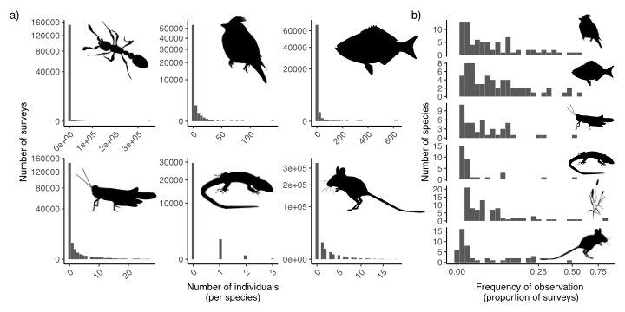

**Figure 1.** Two dimensions of rarity that highlight that rarity is the norm in ecosystems across the globe. Here, we show that most species are (a) rare in abundance across sampling surveys and (b) detected in relatively few sampling sessions. We demonstrate this general pattern for a diversity of taxa across systems, including terrestrial and marine animals and plants. (Data from: [cite data sources here]).

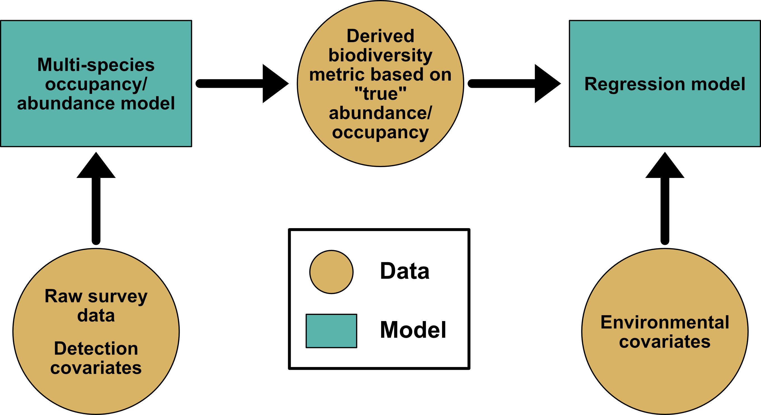

**Figure 2.** A general modeling approach for accounting for imperfect detection of rare species. The approach combines surveys (occurrence and/or abundance) of individual species with multi-species occupancy and abundance models (MSOM/MSAM), accounts for detection errors within the MSOM/MSAM models, propagates uncertainty from those models to estimates of biodiversity indices, which are subsequently regressed on environmental covariates to uncover factors governing changes in diversity. Data or model inputs are represented as brown circles; models as teal squares.

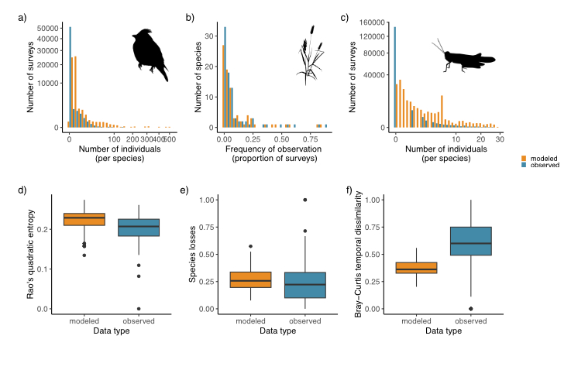

**Figure 3.** Distributions of abundances and occurrence when ignoring (blue) or accounting for (yellow) detection error for three example datasets: (a) birds at the Konza Prairie Long-term Ecological Research Site, Kansas, USA, (b) plants at Petrified Forest National Park, Arizona, USA, and (c) grasshoppers at the Sevilleta Long-term Ecological Research Site, New Mexico, USA. Results show how accounting for imperfect detection alters estimates of a variety of biodiversity metrics based on abundance for (d) birds (Rao’s quadratic entropy), occurrence for (e) plants (species turnover) and abundance for (f) grasshoppers (Bray-Curtis dissimilarity). In all three, accounting for imperfect detection shifts species abundance and occurrence distributions to the right (a-c) compared to the observed data that ignores detection errors. Accounting for rare species leads to (d) increases in bird functional diversity, (e) increases in the number of plant species lost over time, and (f) decreases abundance-based dissimilarity for grasshoppers.

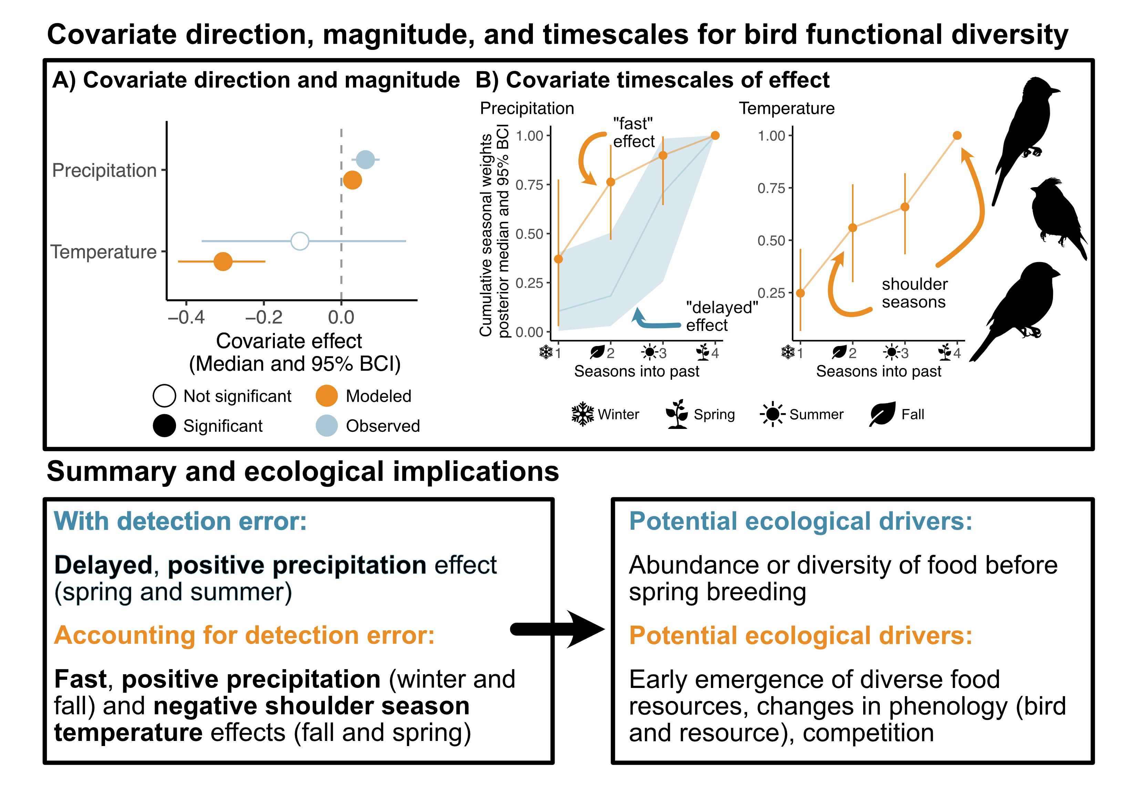

**Figure 4.** Illustration of how accounting for imperfect detection alters estimates of covariate effects and their timescales of influence on bird functional diversity measured as Rao’s quadratic entropy. Data are from species abundance surveys of passerine bird species from the Konza Prairie Long-term Ecological Research (LTER) site in Kansas, USA (CITE DATA SOURCES).

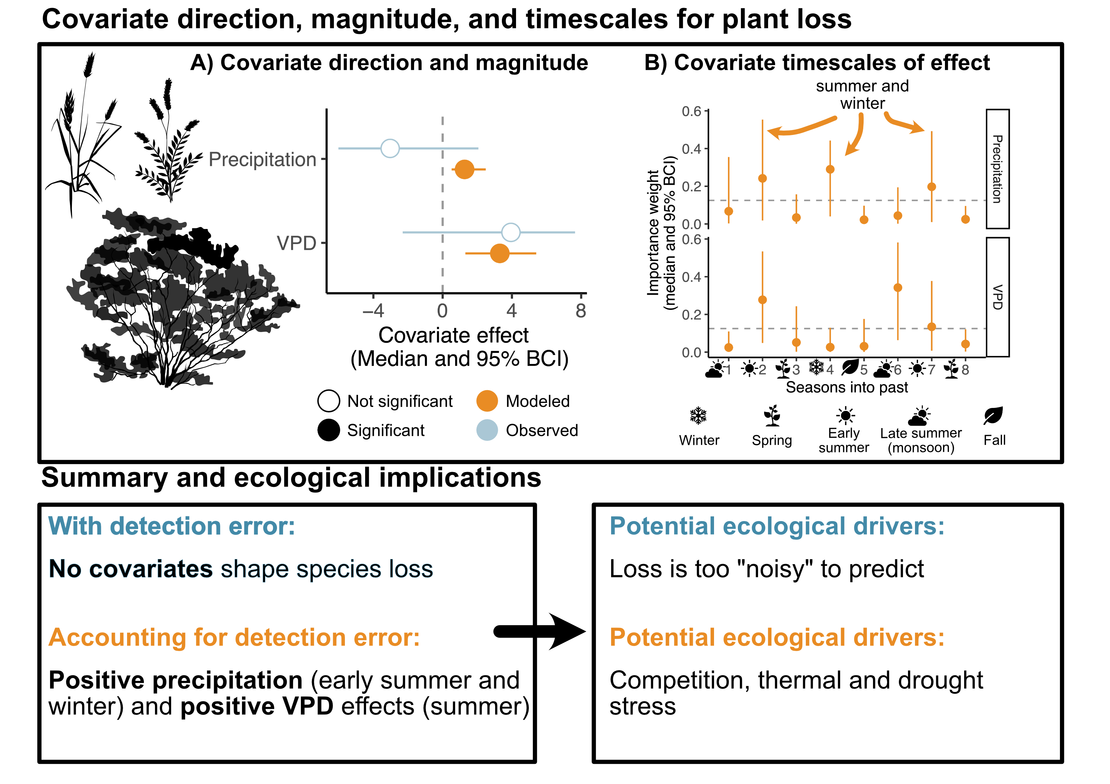

**Figure 5.** Illustration of how accounting for imperfect detection alters estimates of covariate effects and timescales of influence on plant species loss for the Petrified Forest National Park, Arizona, USA understory plant community ([CITE DATA SOURCES])

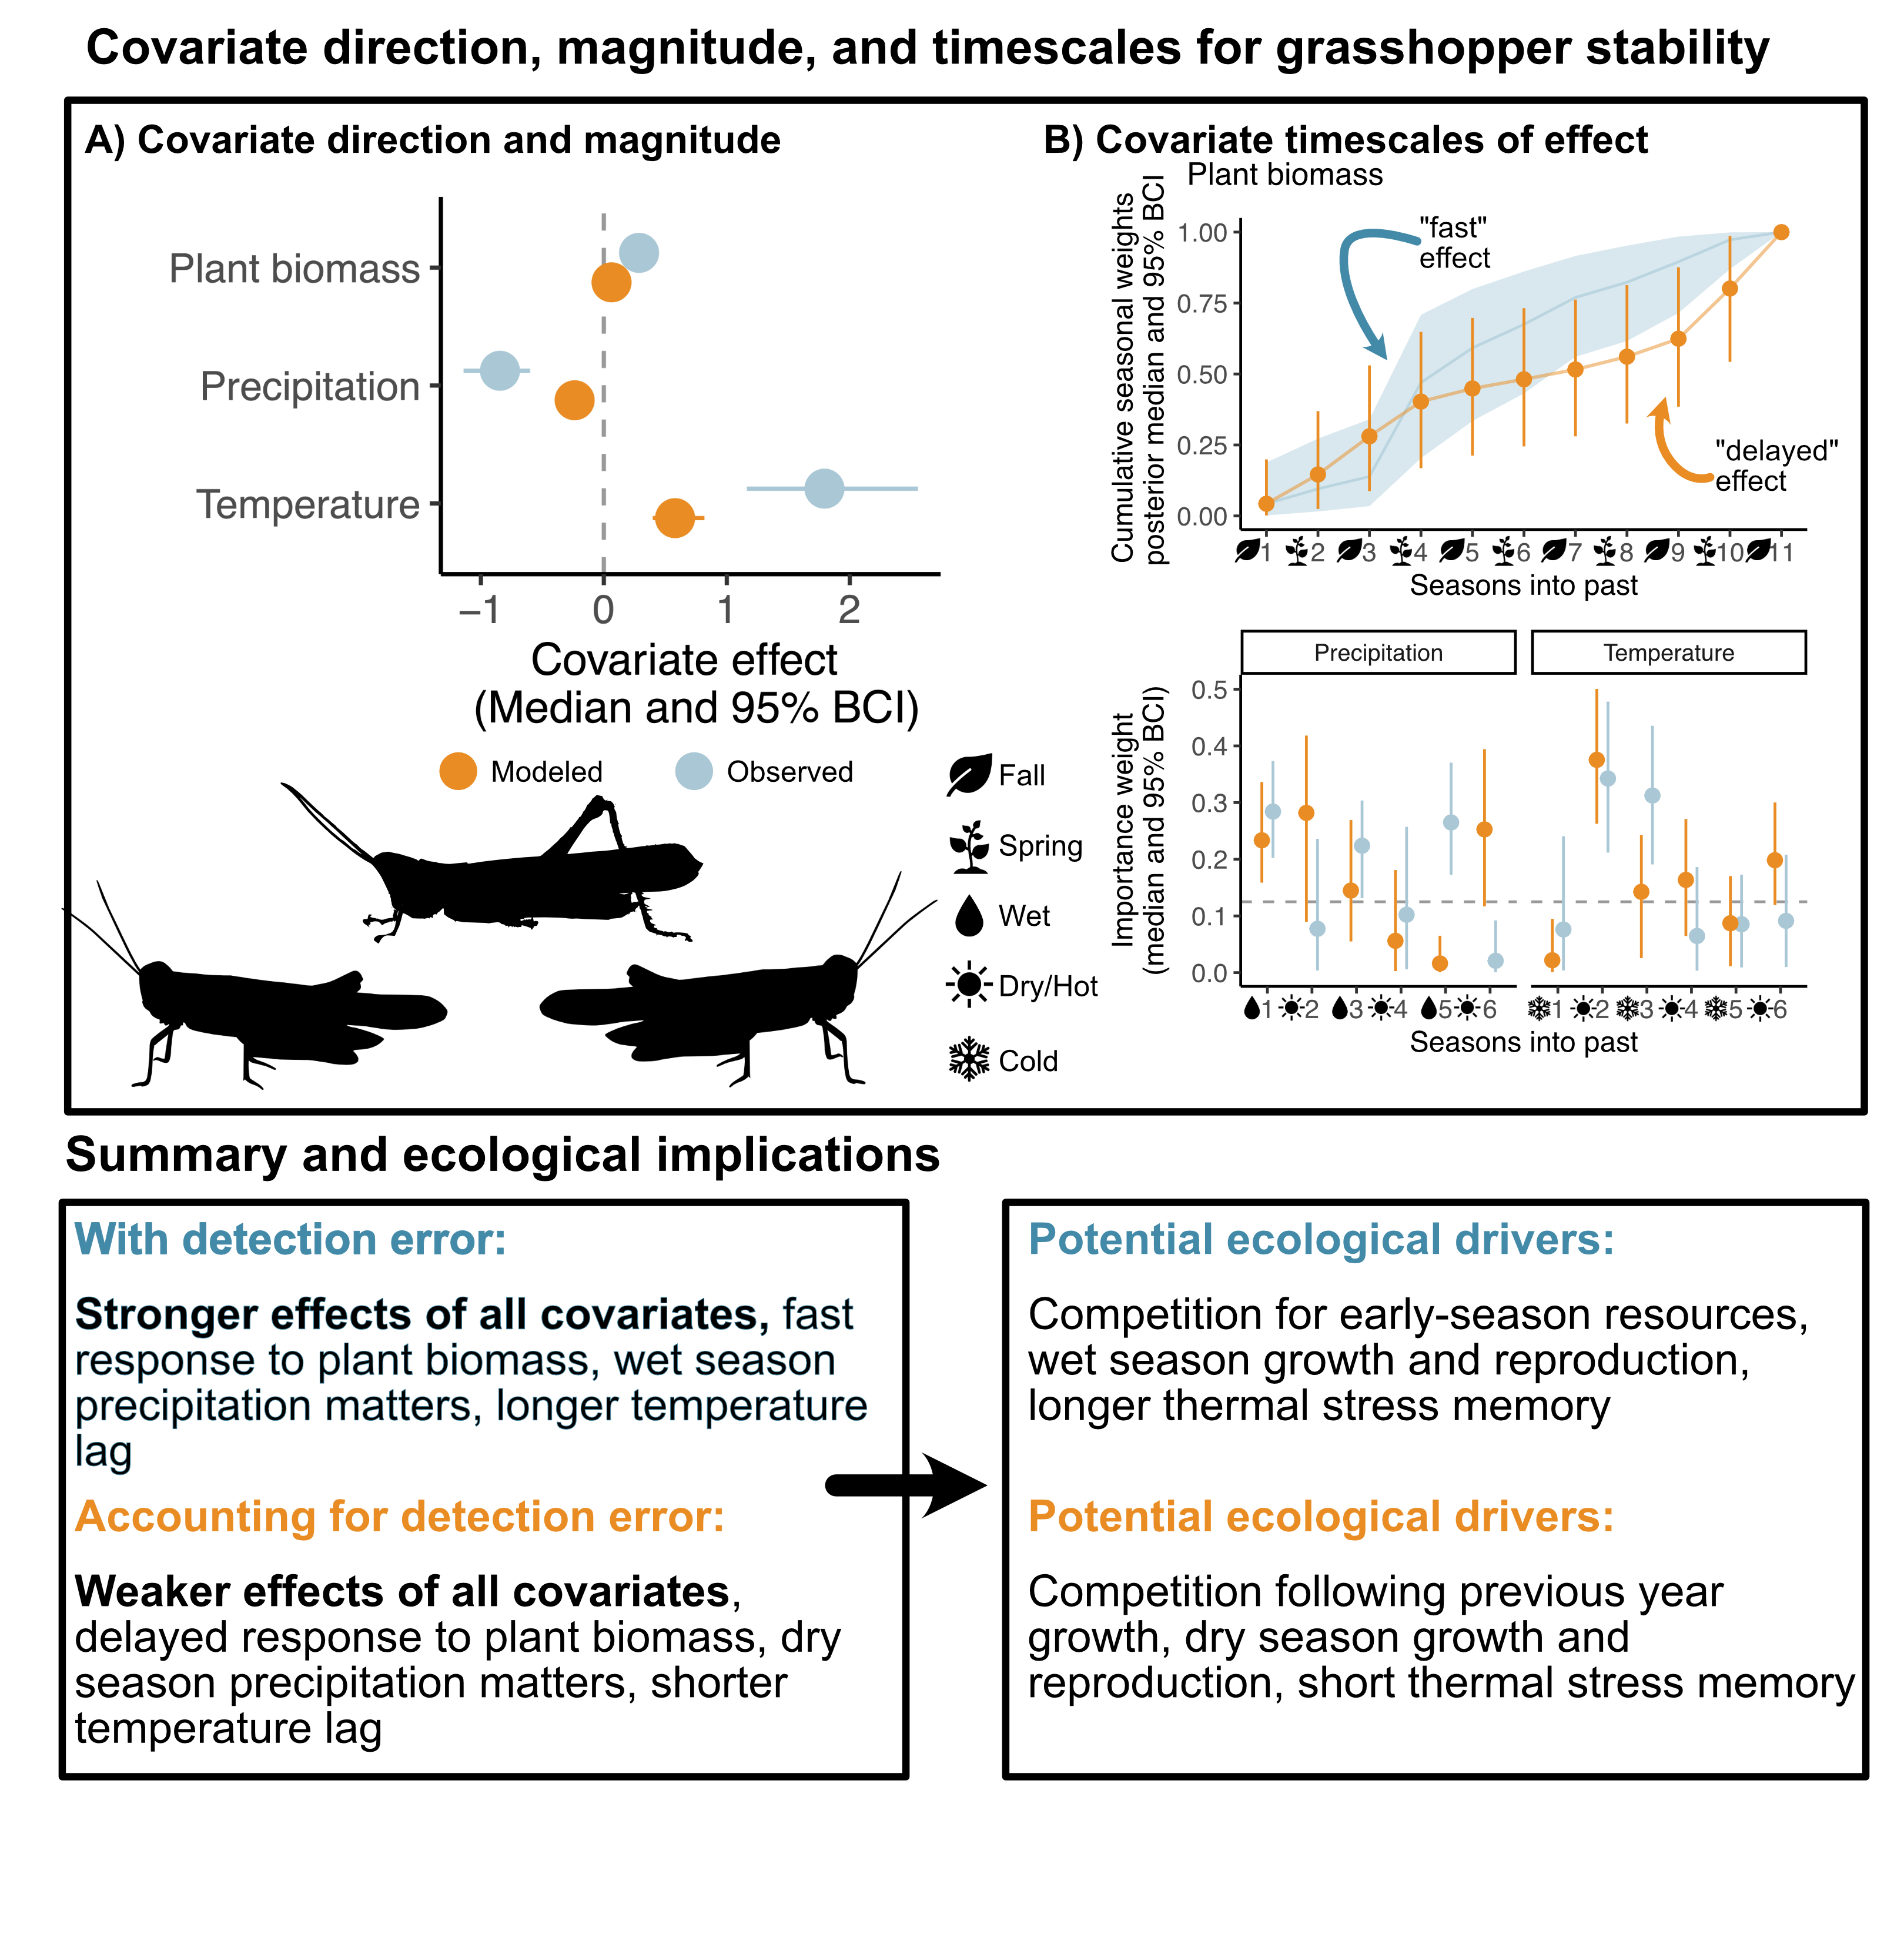

Figure 6: Illustration of how accounting for imperfect detection alters estimates of covariate effects and timescales of influence on temporal stability of grasshopper communities based on Bray-Curtis dissimilarity. Data are from surveys of grasshopper species abundance from the Sevilleta Long-term Ecological Research (LTER) site, New Mexico, USA (CITE DATA SOURCES) Accounting for imperfect detection alters estimates of covariate effects and time scales on temporal stability of grasshopper communities based on Bray-Curtis dissimilarity.